

Proposed Database Design For House Rental Management system



October 17, 2019

Presented by

Abrar Hossain Asif (ASH1825005M)

Rahat Uddin Azad (ASH1825020M)

Al Jaber Nishad (ASH1825029M)

Kamruzzaman Shekh (ASH1825035M)

**Overview**

Roam around to rent a house has always been a hassle for people. Especially, on recent times, people have so many priorities based on which they have to rent their house. Some people want their house to be in the commercial space, or some want in a chaos free space. Some people prefer to choose the area of their house relating the religion they belong. Again, there are a lot of people who love pets; therefore, they want a house which has pet allowance. Basically, in this era of modernism people want to rent their house like online shopping. To rent a house in physical world has become less popular now a days. No one wants to roam around here and there to search for a house. People would prefer a virtual system to rent a house. In general youths face much bigger problems while renting a house. They don’t give house on rent to bachelors and lot of rules and restrictions by the landlord. To decode this situation and to represent a hassle-free environment to the people a dynamic system can be implemented. We represent a home rental system which provides every needed facility the primary focus of our work is to implement constraint satisfaction problem in the search option of our home rental system. Our home rental system will have dynamic values for searching and for which constraint satisfaction problem implementation is a better preference. Not only this but also a combination of public transport tracker and a dynamic chat server between admin and agent is also a feature of this rental system. Additionally, there is a dynamic mail alert system in which if any user put any request in the wish list, they will be notified by this system.

**Entity Relational Diagram**

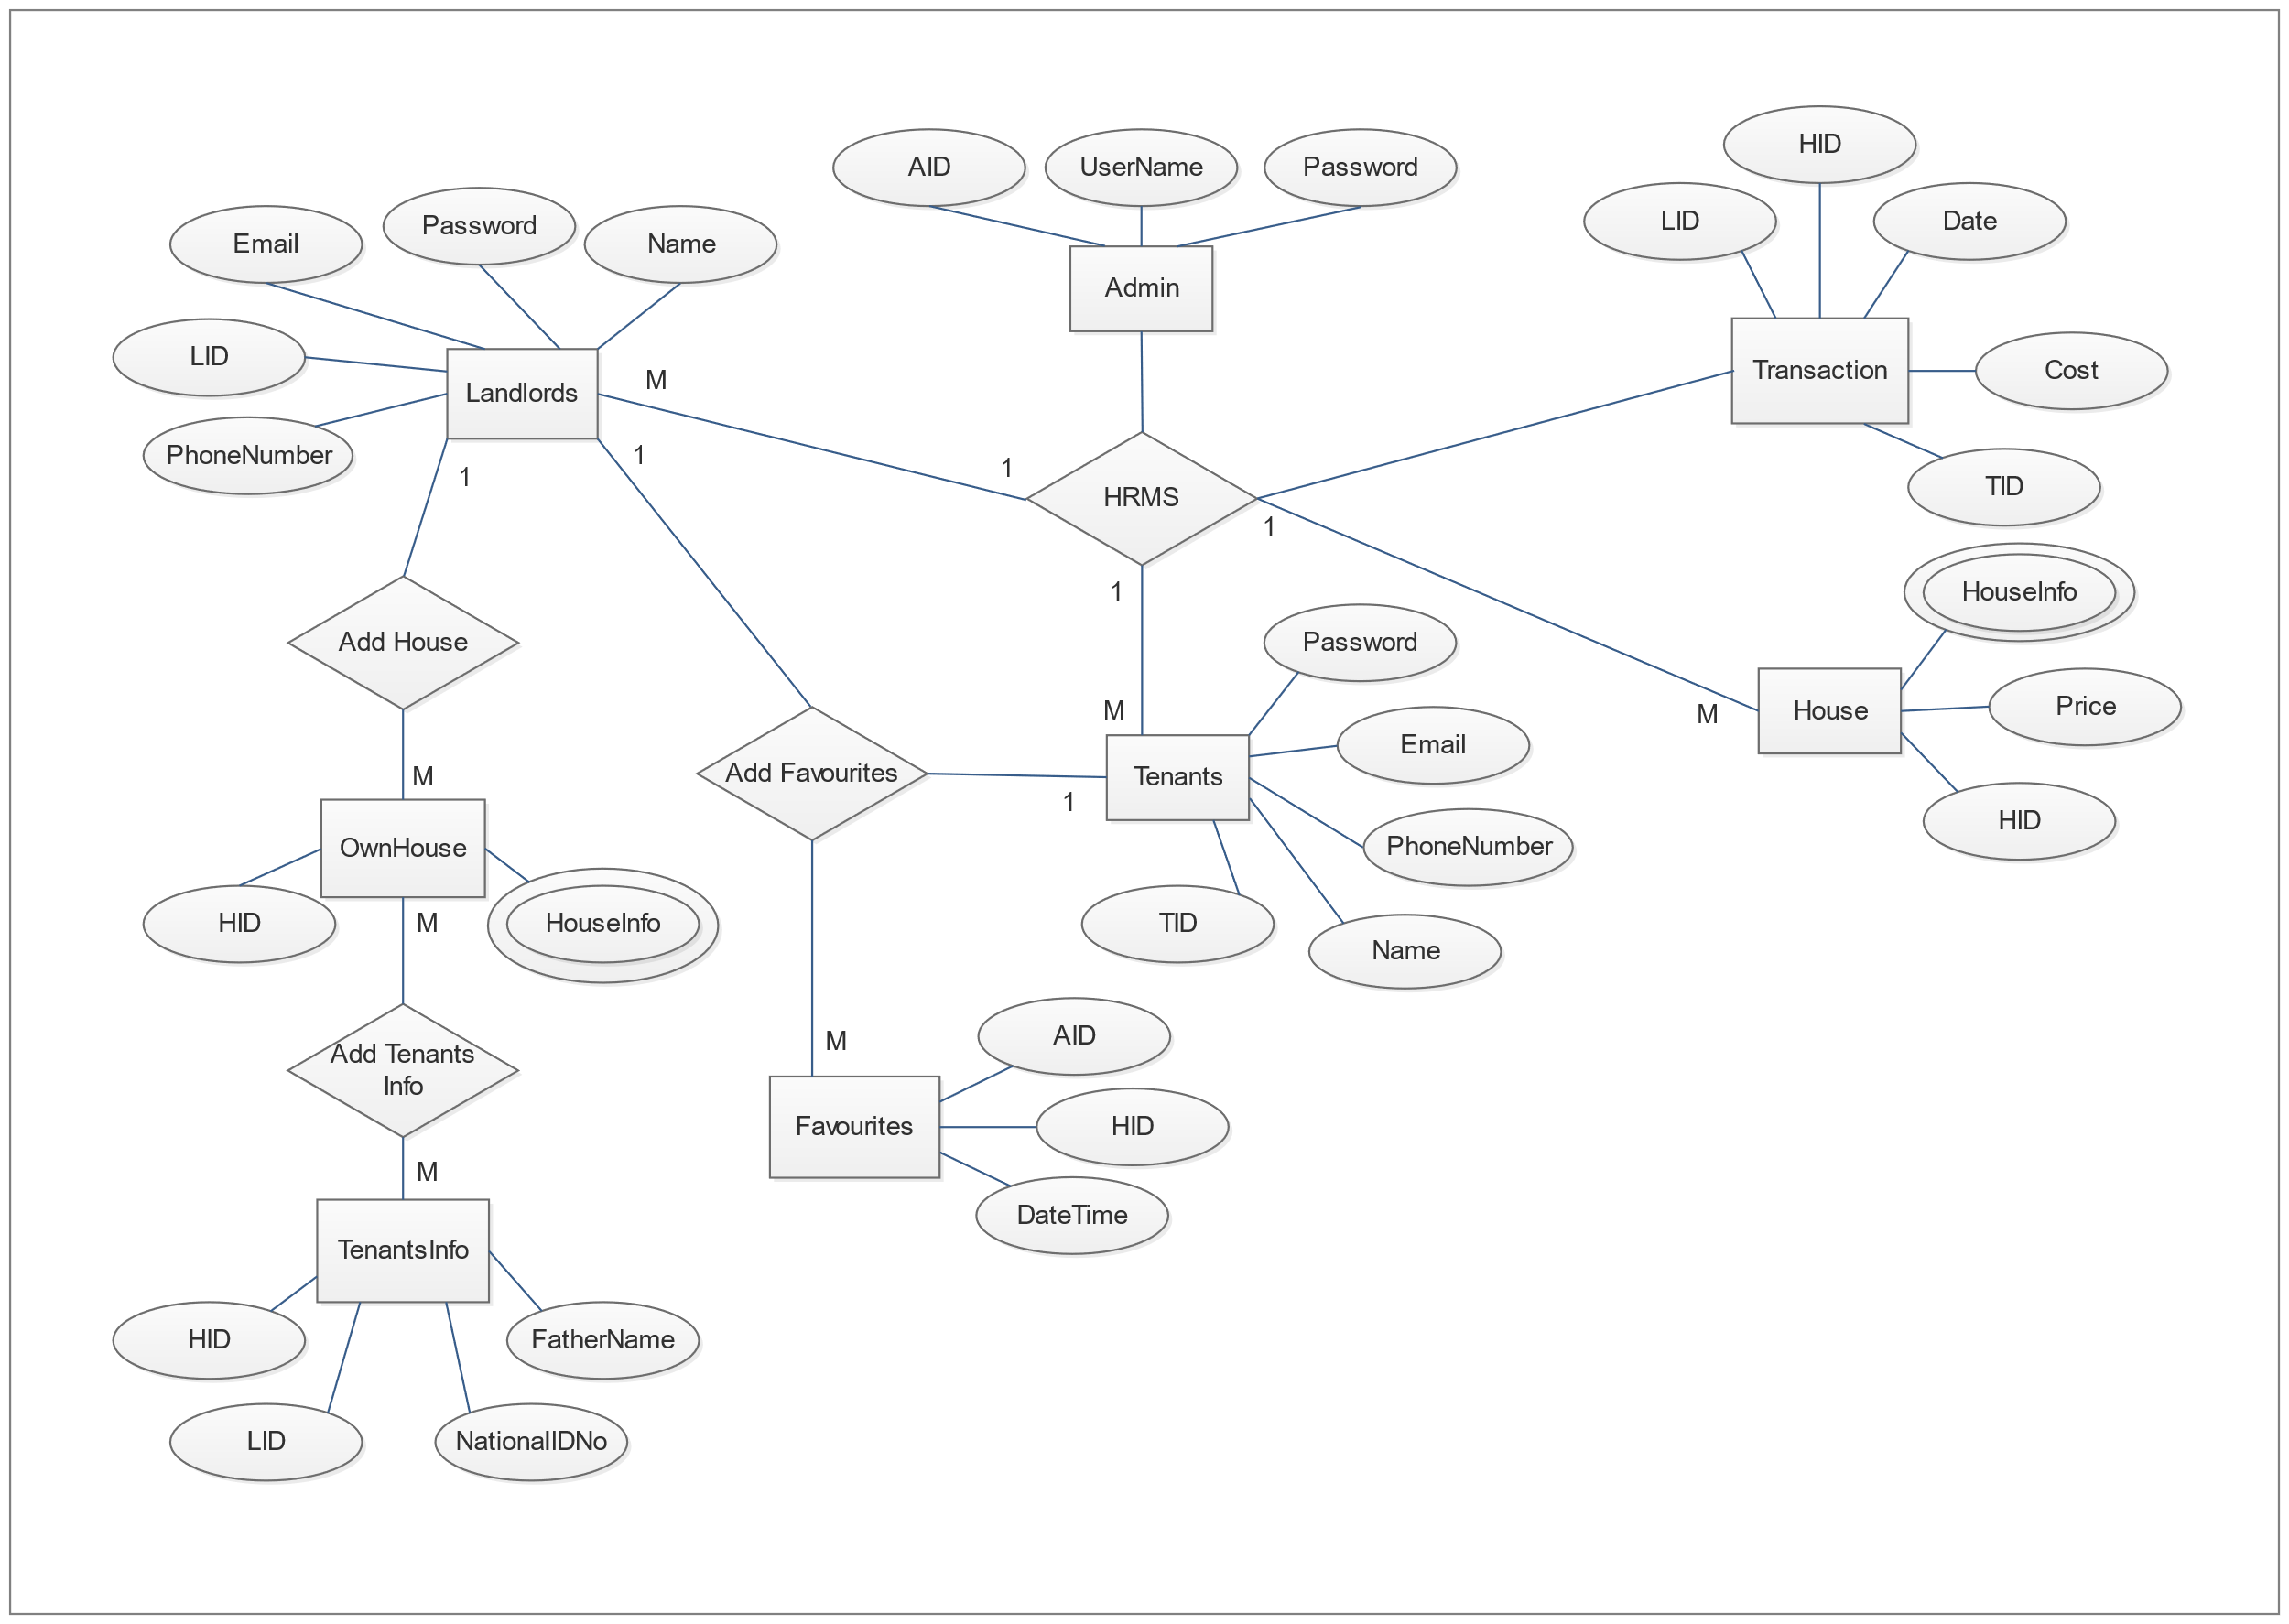

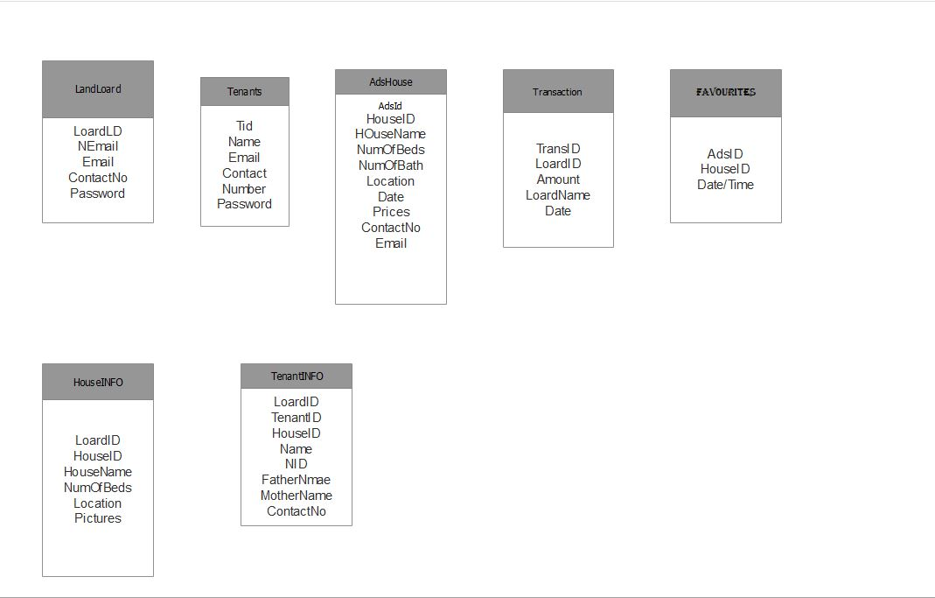**Database schema**

**1st Normalization Form**

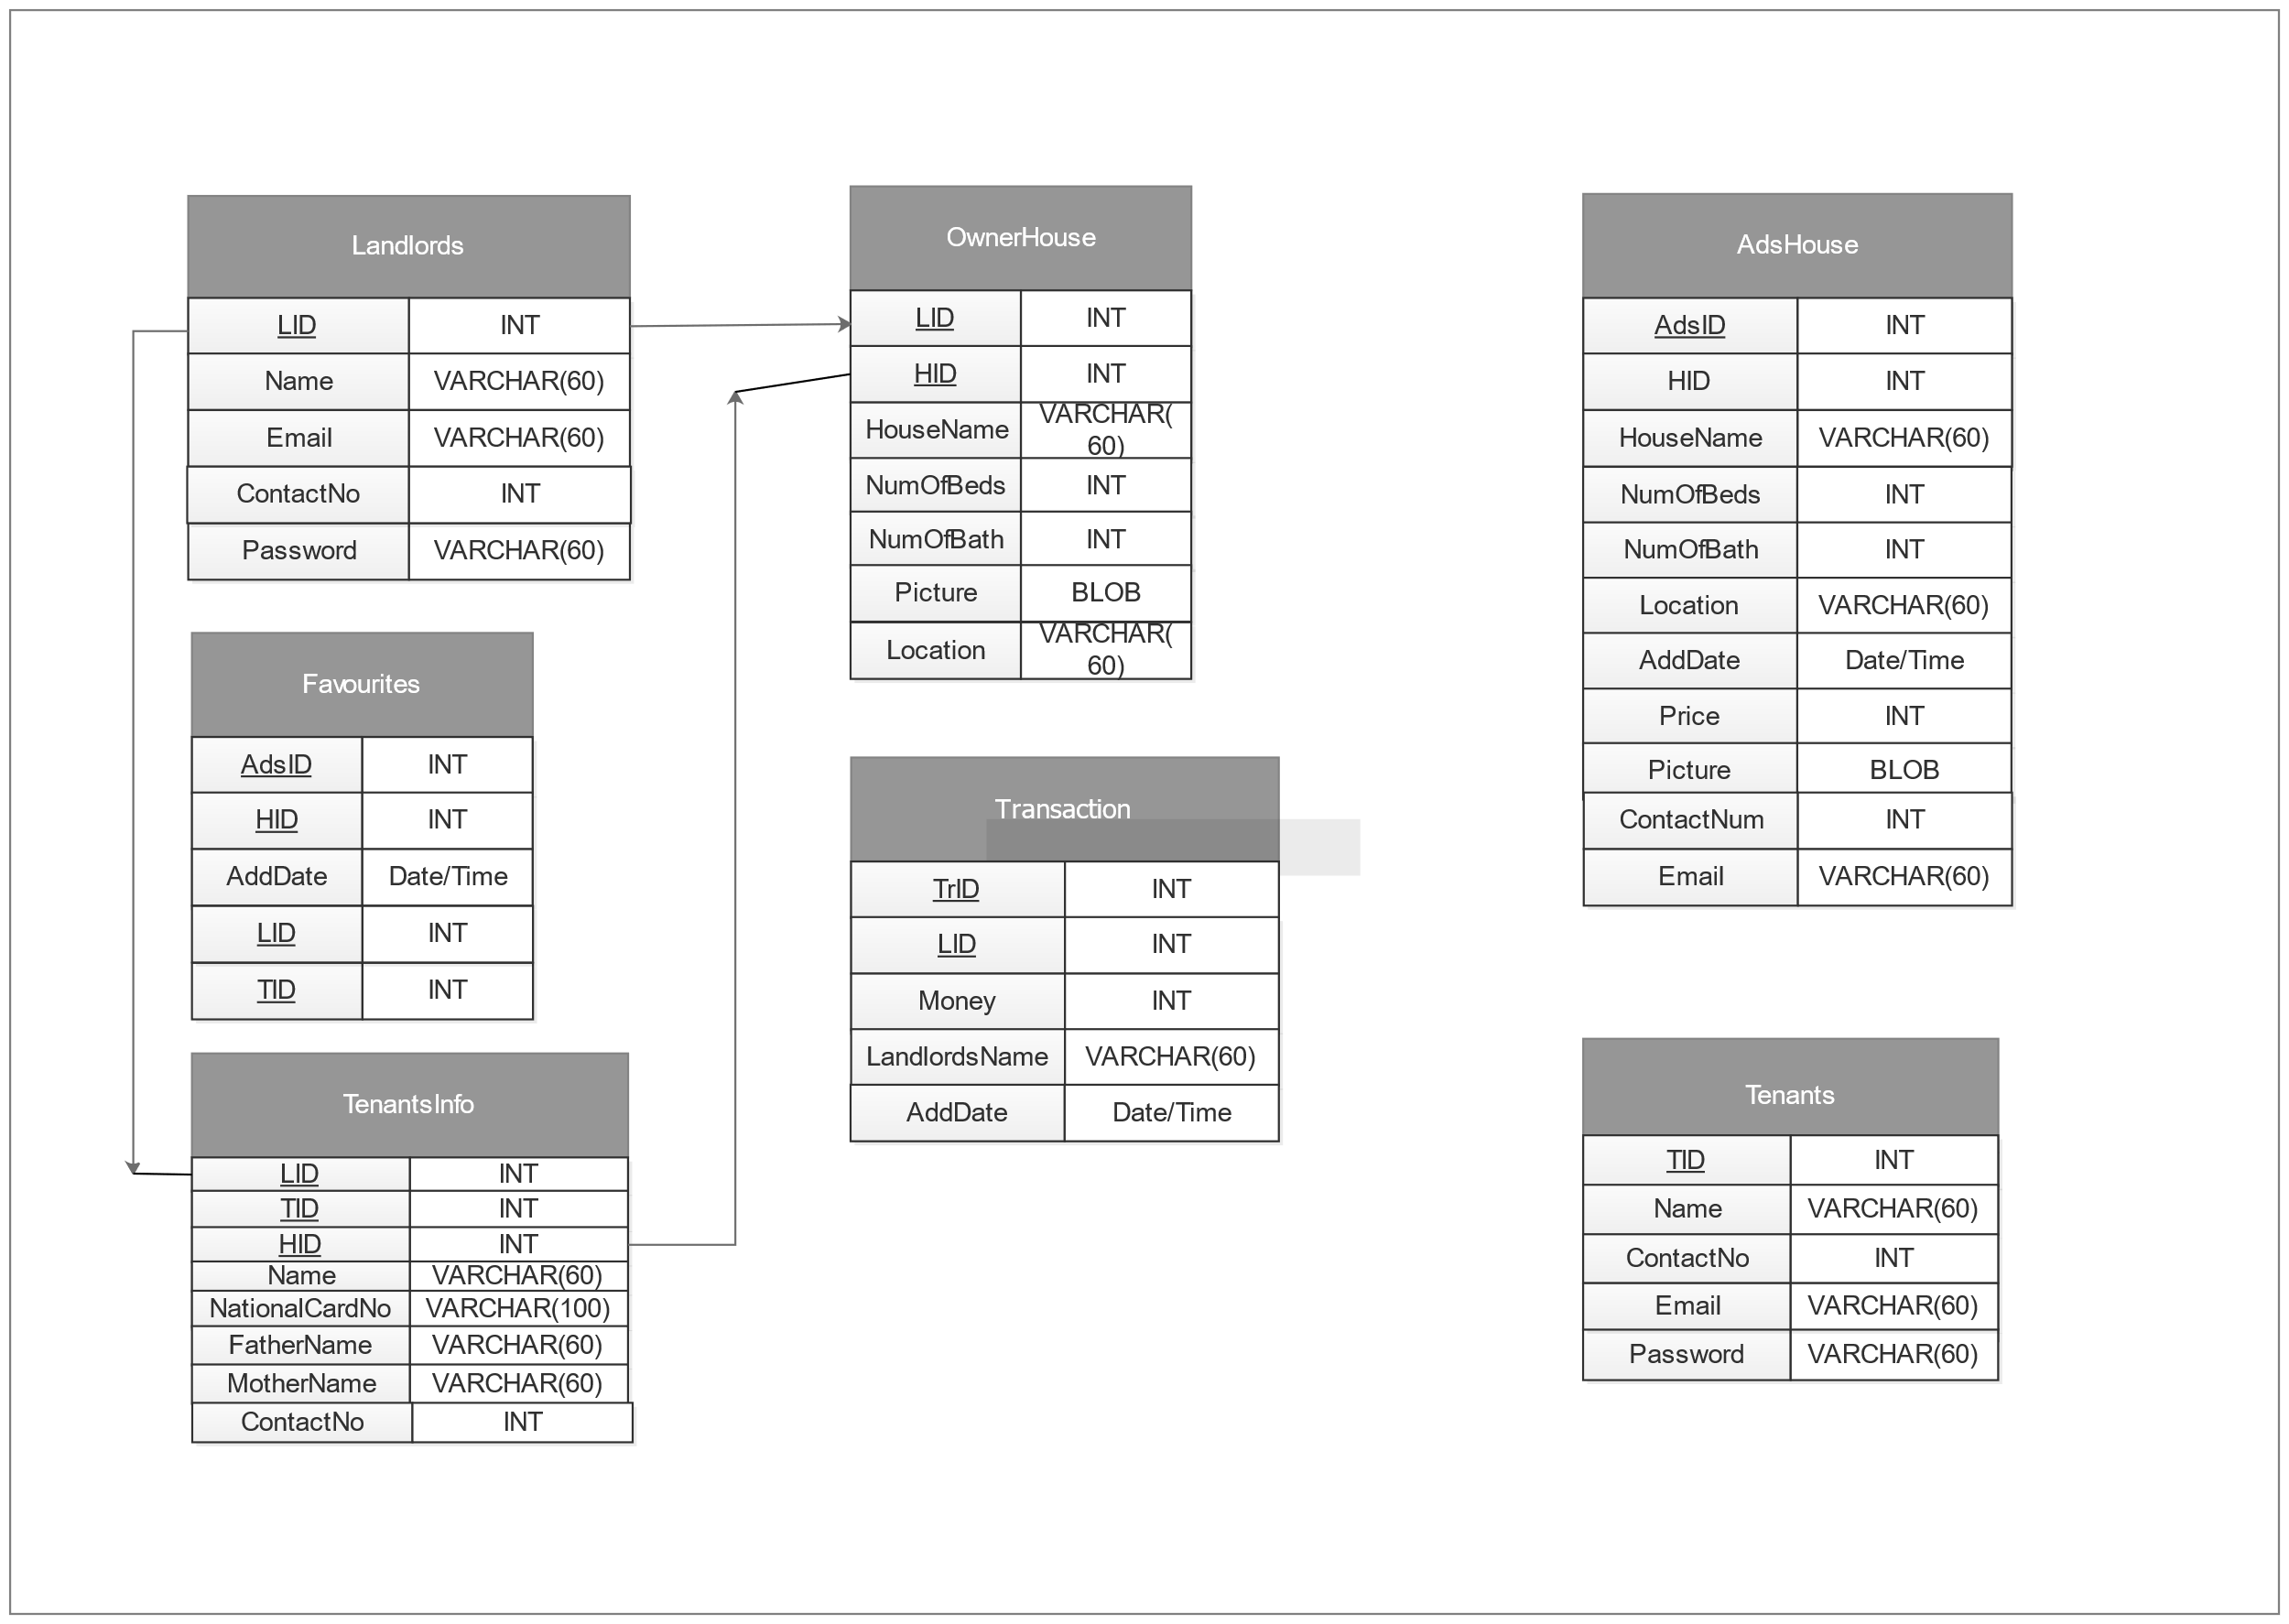

**2nd Normalization Form**

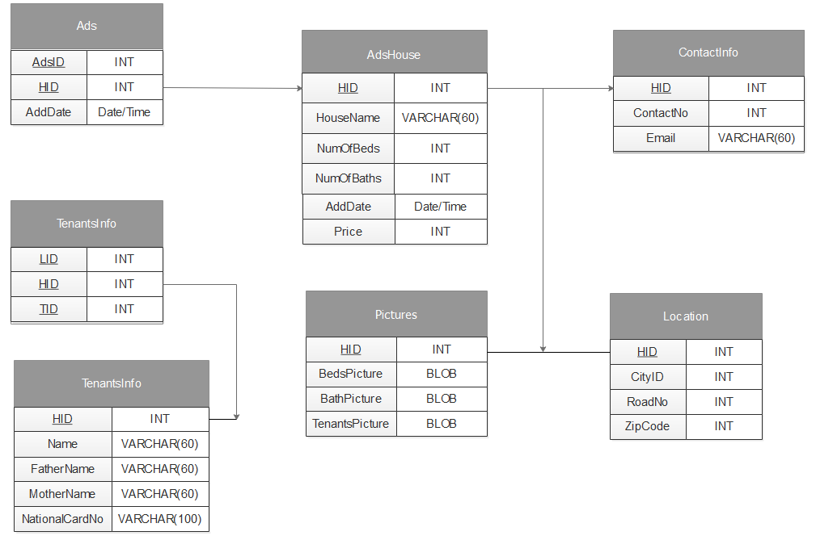

**3rd Normalization**

